Structural Operational Procedure : Creating an AWS S3 Bucket
Objective
To create an Amazon S3 bucket for storing and managing objects (files and folders) in AWS Cloud.

Prerequisites
- AWS Account
- IAM User with S3 permissions
- Access to AWS Management Console
- Internet connection

Procedure
Step 1: Login to AWS Console
- Open AWS Management Console.
- Enter your credentials.
- Select the desired AWS Region.
  - Region Selected: Asia Pacific (Mumbai) - ap-south-1
Expected Result: AWS Console Home page is displayed.

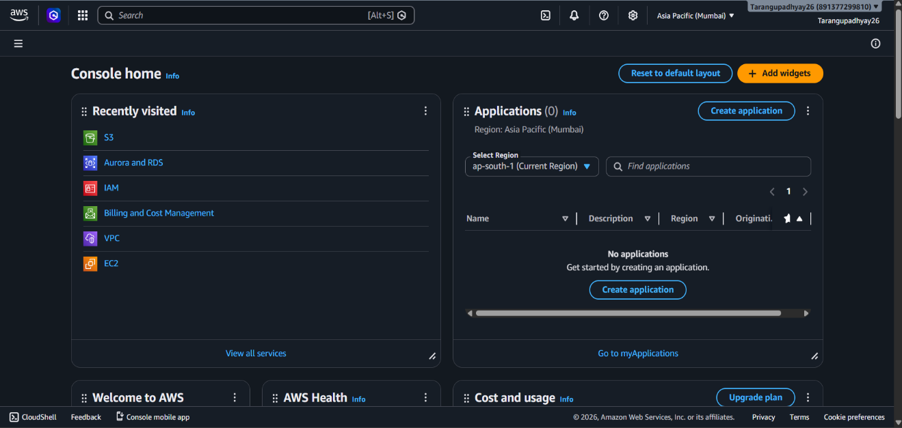

Step 2: Open Amazon S3 Service
- Search for S3 in the AWS Search Bar.
- Click on Amazon S3.
Expected Result: Amazon S3 Dashboard opens.
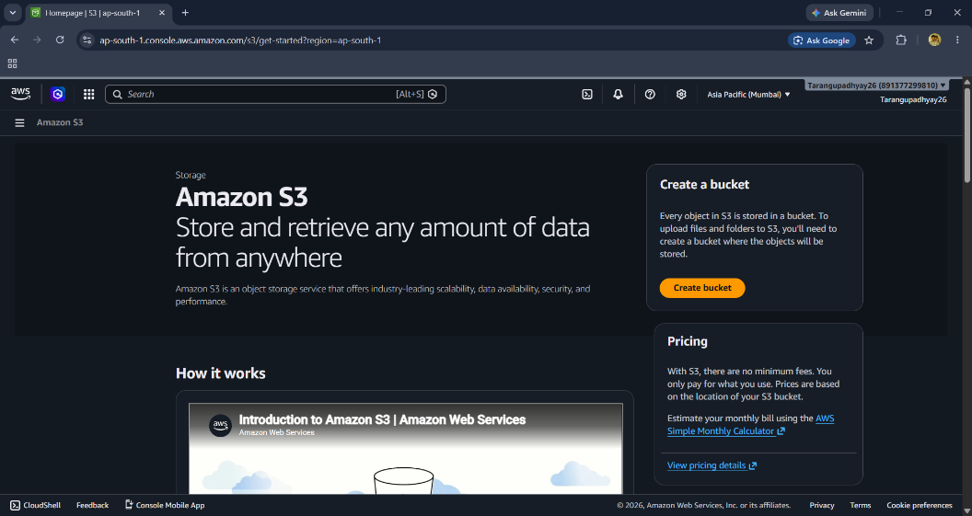

Step 3: Create a New Bucket
- Click Create Bucket.
General Configuration
Setting | Value
AWS Region | Asia Pacific (Mumbai)
Bucket Type | General Purpose
Bucket Namespace | Global Namespace
Bucket Name | demo-bucket
Note: Bucket names must be globally unique.
Example:
tarang-demo-bucket-2026
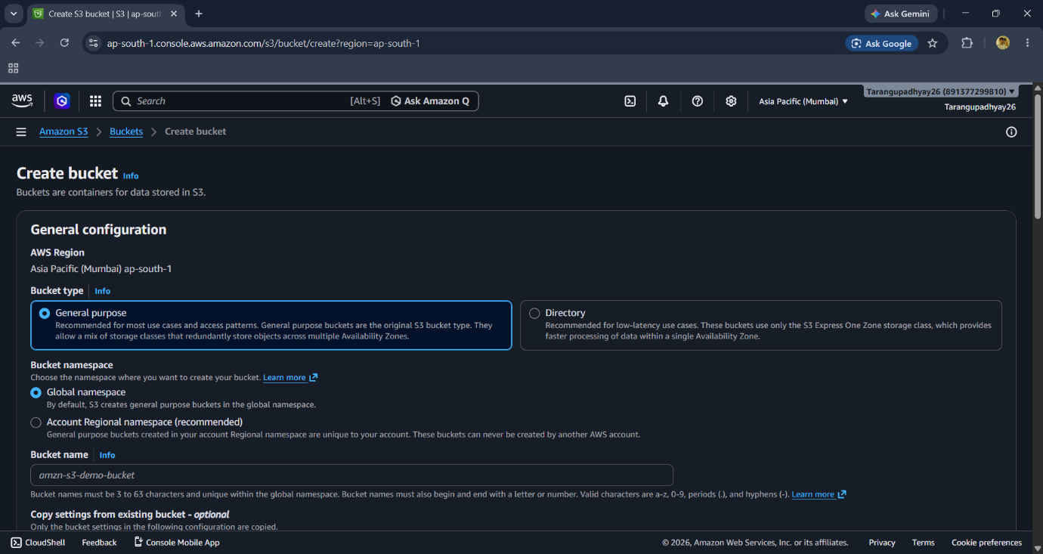

Step 4: Configure Object Ownership
Select:
✅ ACLs Disabled (Recommended)
Reason:
- Bucket owner gets full control over uploaded objects.
- Simplifies permission management using Bucket Policies and IAM.
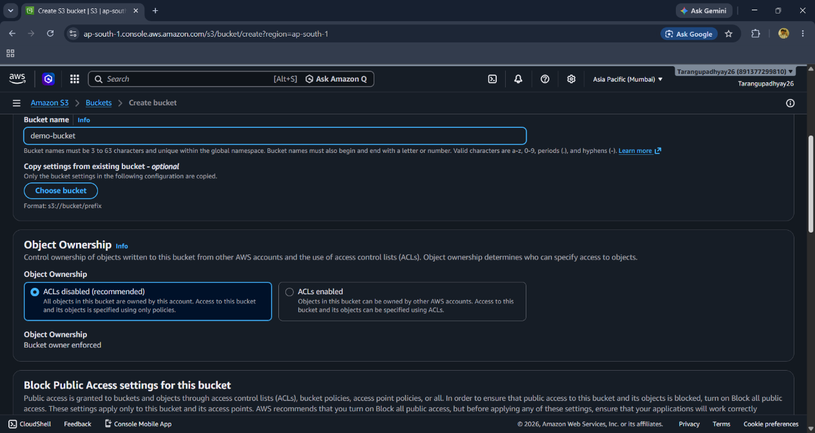

Step 5: Configure Public Access Settings
Keep:
✅ Block All Public Access
Enabled Options:
- Block public ACLs
- Ignore public ACLs
- Block public bucket policies
- Restrict public bucket policies
Reason:
- Prevents unauthorized access.
- Recommended by AWS for security.
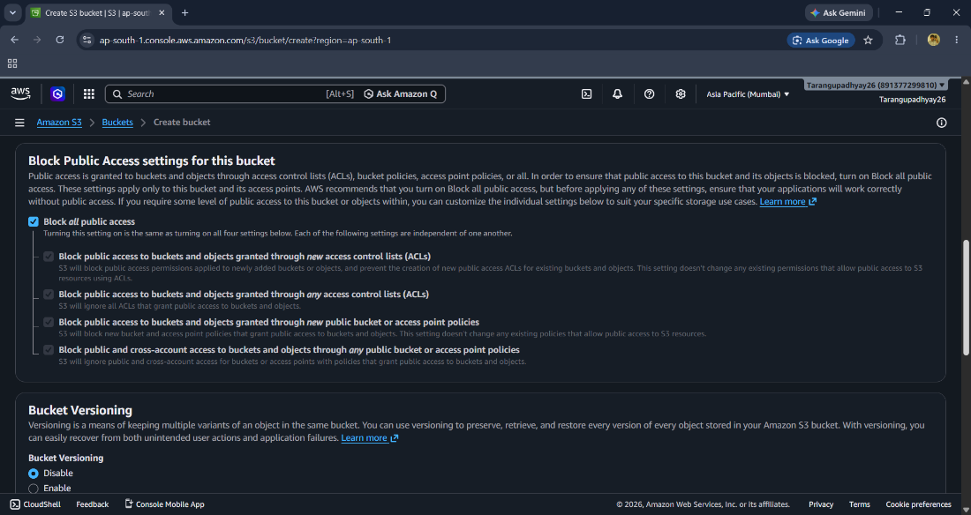

Step 6: Configure Bucket Versioning
Select:
✅ Enable Versioning (Recommended)
Purpose:
- Stores multiple versions of an object.
- Protects against accidental deletion and overwrites.
Example:
File1.txt
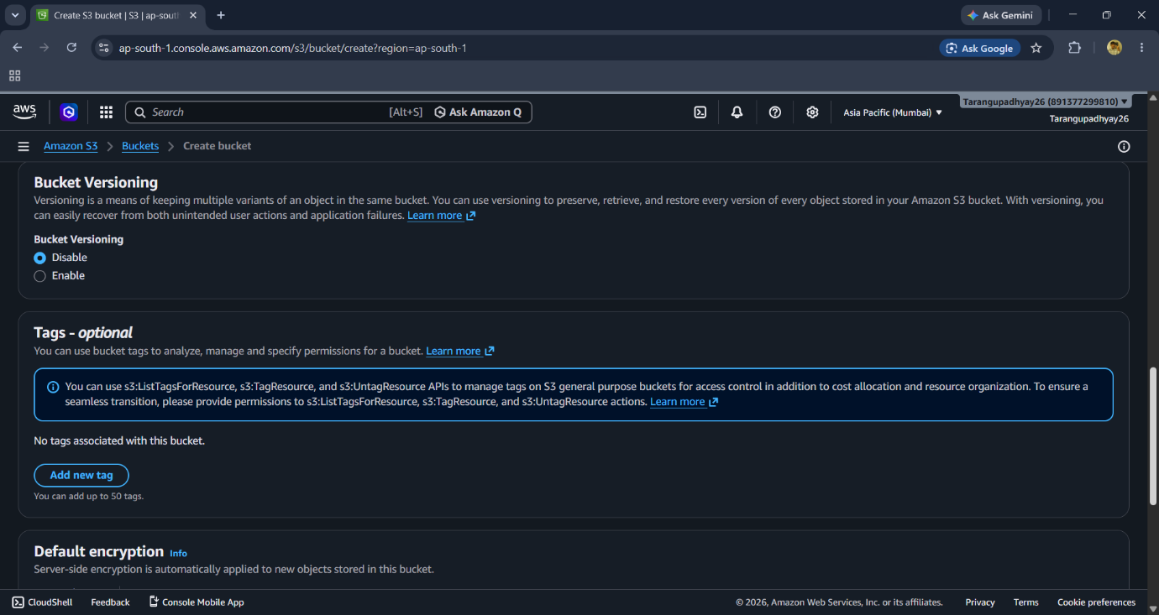

Step 7: Configure Default Encryption
Scroll down to Default Encryption.
Select:
✅ Server-side encryption with Amazon S3 managed keys (SSE-S3)
or
✅ AWS KMS Keys (for advanced security)
Purpose:
- Encrypts data at rest. 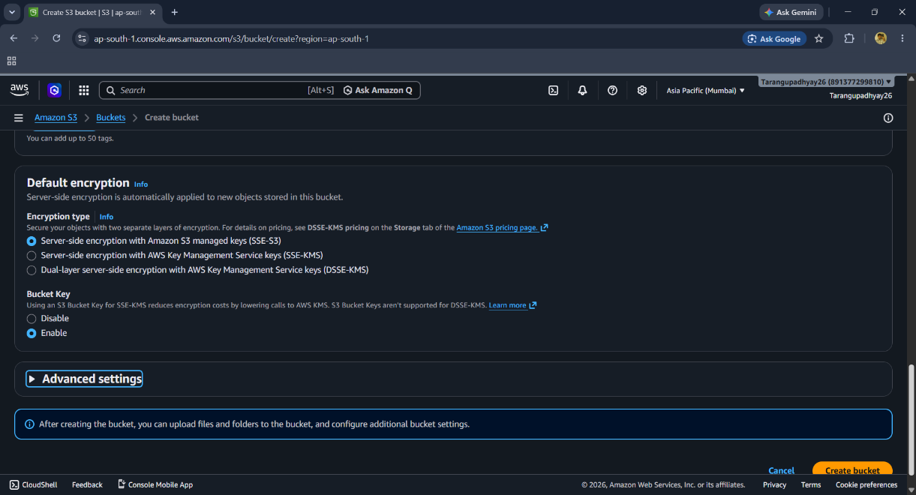
Step 8: Review Settings
Verify:
- Region is correct
- Bucket name is unique
- Public access is blocked
- Versioning enabled
- Encryption enabled

Step 9: Create Bucket
Click:
Create Bucket
Expected Result:
A success message appears and the bucket is listed in the S3 Buckets dashboard.

Step 10: Upload an Object
- Open the newly created bucket.
- Click Upload.
- Select a file.
- Click Upload.
Example:
resume.pdf
image.png
project.zip
Expected Result: File is stored successfully in S3.
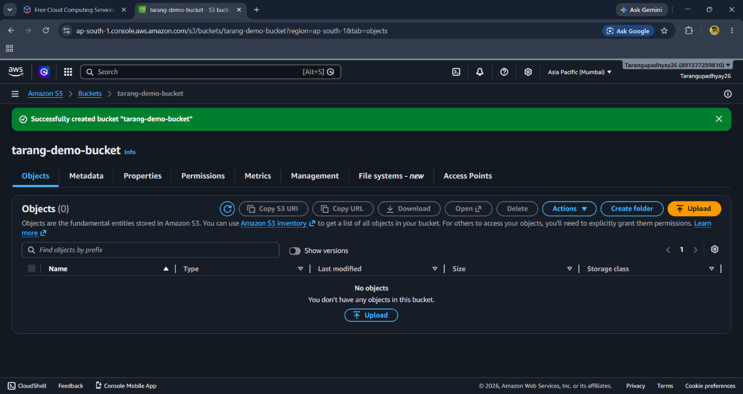

Verification
Confirm:
- Bucket appears in S3 Bucket List.
- Bucket status is Active.
- Uploaded objects are visible.
- Versioning is enabled.
- Public access remains blocked.

Security Best Practices
✅ Enable Versioning
✅ Enable Encryption
✅ Keep Public Access Blocked
✅ Use IAM Roles instead of Root User
✅ Follow Principle of Least Privilege
✅ Enable CloudTrail Logging

Outcome
Amazon S3 Bucket has been successfully created in the Mumbai Region with secure access controls, versioning, and encryption settings, allowing safe storage and retrieval of data in AWS Cloud.

